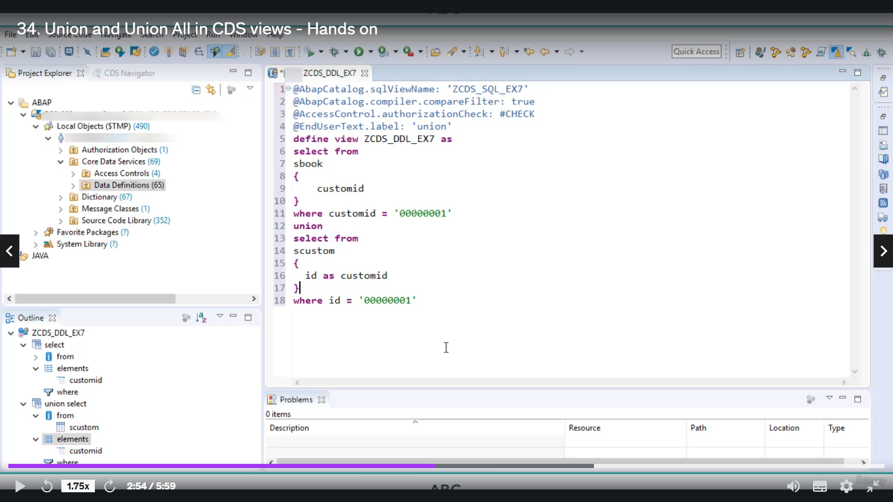

IF SAME NAME IS NOT AVAILABLE THEN YOU CAN USE ALIAS TO MATCHA THE NAME CRITERIA

Now, I hope you know, how do you join Nestor to join in about the issue and how you can filter out

the results using their claws?

Now let's create a Web series to you, see how you can use union their name as examples seven, which

is a union

related to this union name.

The next year, there is no special template for union.

So I will select define view.

OK, now let's quickly denied this good morning.

Now, here in this example to explain you the working of union, I will take one food from table as

book.

We will take a single food to keep it simple, and that is customary.

Let's put a limit on the ResultSet using clause of fear, because comedy equates to zero one.

So this will be one Siliguri.

As you know, that union is used union and union.

All these key words are used to combine a result of multiple queries.

So here you have to write one woozily.

During

this time, I will read from Table as custom.

And I will read the field

custommade.

OK.

Uh, my mistake, and there is no we'll call customary in custom, did its full name I.

Then we will put similar condition to limit the desert here.

It would be ideal.

So here we go to an error and the error is still, at least with the union, must have the same name.

OK, here, the select list should have the same name of it.

If it is not same, then you can use alternate name to fill ideas.

Customer.

So now you can see that data has gone.

So let's make sure that when you whenever you are using union and union all keywords, you are fulfilling

the prerequisite to use those keywords.

OK, now let's see if this idiot could get executed, what will be the reason for that purpose?

You are to open his book.

And here we are two to one, since we have written one, so now you can see there are 27 records.

Similarly, let's see what will be the result of this very good executed.

For that purpose, we have to go to a custom table.

Now, here you have to keep it as one and execute so you will get a single record.

So that means if I combine these two records with union, all this key word, then I should get twenty

eight record ed.

Snowless activities for.

Uh.

So you can see in the results that you have 28 reports since you using union all over it will combine

the result of these two select queries and will not remove any duplicate entries.

Here you can see all the records on the column customarily contain, well, one and the total number

of indices, 28 means duplicated records are not removed from place of union or left right union.

And let's see what we are put in this case.

So now here you can see the customary will contain only a single record, zero one, that is because

if you are using your union to combine multiple queries, it will remove duplicate records.

And that's why there is only you have only one recording this column.

Now, I hope you understood how you can use union and union all in about two years.